**Annual Zonal Workshop of KVKs under ICAR-ATARI Kolkata organized**

*27th-29th August, 2024, Puri*

The Annual Zonal Workshop of KVKs under ICAR-ATARI Kolkata was organized by ICAR-Agricultural Technology Application Research Institute (ATARI), Kolkata, in collaboration with OUAT-KVK Puri at Toshali Sands, Puri, Odisha. In this program, 59 KVKs from the Andaman and Nicobar Islands (3), Odisha (33), and West Bengal (23) participated and presented their progress reports for 2023-24 and action plans for 2024-25.

Dr. T. Mohapatra, Chairperson, PPVFRA and the Chief Guest of the Inaugural Ceremony, highlighted the immense possibilities in safeguarding farmers' varieties, particularly in integrating them into value chains and unlocking their potential for commercialization. He expressed hope that the discussions during the workshop would shed light on solutions to the challenges facing agriculture and its allied sectors.

Dr. U.S. Gautam, DDG (AE), ICAR and the Chief Guest of the Valedictory Programme, commended the pivotal role of KVKs on a national scale. He envisioned these Farm Science Centers as the quintessential 'Single Window Delivery System' or 'One Stop Solution.' He spoke of the harmonious convergence between KVKs and various Ministries and Departments, suggesting the emergence of unique and transformative initiatives. With foresight, he assured that ICAR is poised to take steps dedicated to the welfare of KVK staff nationwide. In a more intimate breakout session, he emphasized the necessity for ATARIs to engage in in-house research projects, fostering innovation from within.

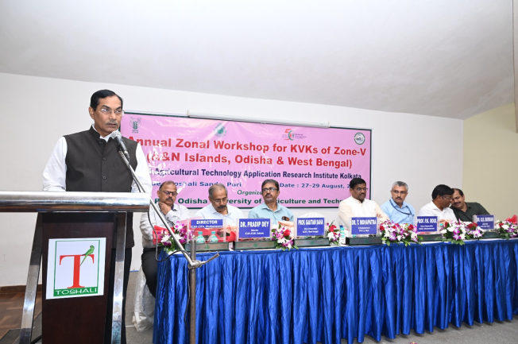 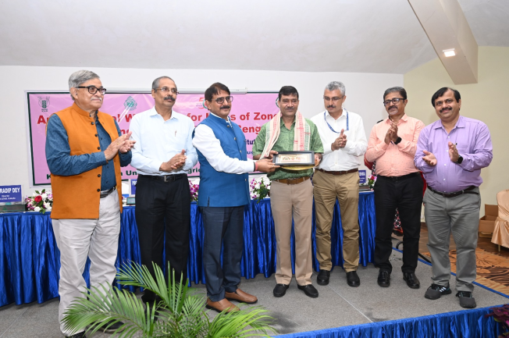

Prof. P.K. Roul, Vice Chancellor, OUAT, Bhubaneswar, commended the KVKs for effectively promoting natural farming technology at the district level and applauded ATARI for its comprehensive achievements, both in physical and financial aspects, across all their projects.

Dr. G. Saha, Vice Chancellor, BCKV, praised the distinctive review system of KVKs and acknowledged their significant contributions to the nation's food and nutritional security.

Dr. R.R. Burman, ADG (AE), ICAR, urged the KVKs in this zone to focus on the transfer of climate-resilient technology, natural farming, capacity building, and providing forward linkage support to FPOs.

Dr. Pradip Dey, Director, ICAR-ATARI, Kolkata, presented results of flagship projects being implemented through KVKs, each a testament to the dedication and innovation of this ATARI. He highlighted the path ahead, emphasizing the transformative potential of KVKs during the Amrit Kal, envisioning them as catalysts and convergence hubs that will propel Indian agriculture towards the nation’s dreams for 2047. He encouraged them to persist in their noble endeavors, not only to uplift the farming community but also to elevate the standing of KVKs in the national arena.

Dr. A.K. Nayak, Director, ICAR-NNRI, Cuttack, suggested that newly developed rice varieties should be included in trials and demonstrations.

Dr. P.K. Sahoo, Director, ICAR-CIFA, Bhubaneswar, suggested that aquaculture offers the best opportunity to boost farmers' incomes.

Earlier in his welcome address, Dr. P.J. Mishra, Dean, Directorate of Extension Education, OUAT, Bhubaneswar, highlighted the contributions of Odisha’s KVKs and the role of the host organization.

A Wisdom Session was arranged, during which Dr. R.K. Samanta and Dr. M.M. Adhikary, former Vice Chancellors of BCKV, Dr. Pranjib Kumar Chakrabarty, former Member, ASRB & ADG-PP, ICAR as well as Dr. H.K. Senapati, Chairman of ZMC, NICRA for Zone-V, deliberated on future extension requirements. Dr. Bikash Das, Director of ICAR-NRC on Litchi, discussed the challenges and opportunities for litchi cultivation in the region.

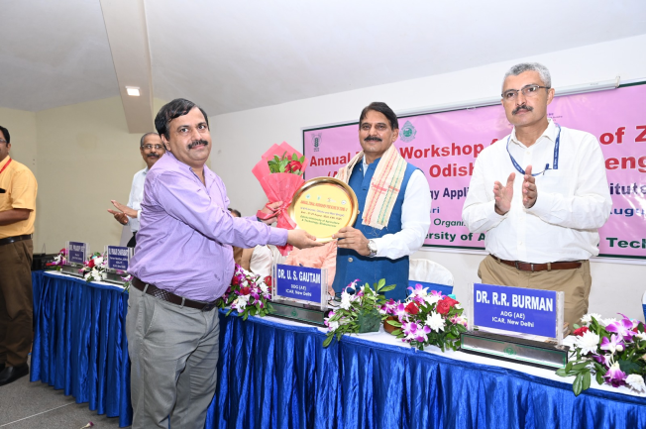 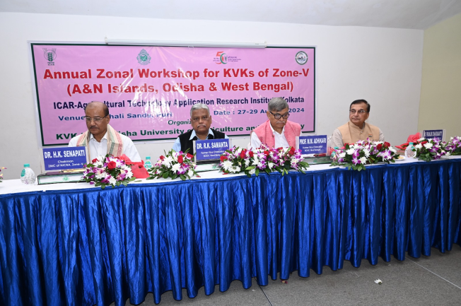

Thirty-four publications including books, booklets/bulletins, folders and four CDs from ATARI Kolkata and various KVKs were released during the occasion.

The KVKs presented their achievements for 2023-24 and action plans for 2024-25 in three concurrent technical sessions, and the reports from all technical sessions were presented in the Valedictory Session. Special sessions were arranged on plant protection and the KVK portal.

A cultural programme was also organized, where Abhinna Sundar Gotipua Nrutya Parisad, Puri, showcased the Gurukul tradition of performing arts and Odisha culture.

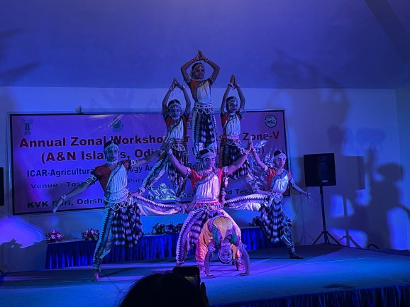 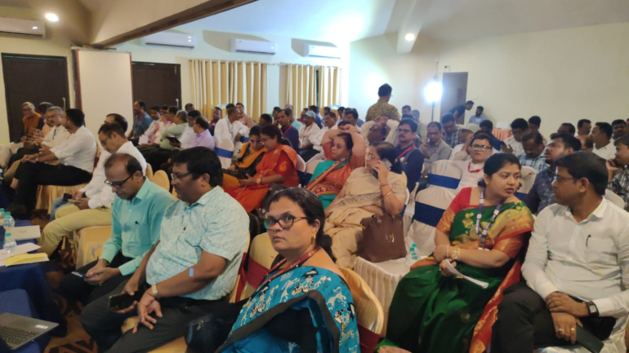

More than 100 people, including the Chairperson of PPVFRA, DDG (AE), Vice-Chancellors, ADG (AE), Directors of various ICAR institutes, DEEs/Principals, Principal Scientists from ATARI Kolkata, scientists from ICAR Institutes and OUAT, Heads of KVKs, SMS/Staff of OUAT-KVKs, attended the workshop.

The workshop concluded with a vote of thanks.

*(Source: ICAR-Agricultural Technology Application Research Institute Kolkata)*