‘Vigilance Awareness Week-2020’ celebrated at ICAR-Agricultural technology Application Research Institute (ATARI) Kolkata

Kolkata, 27.10.2020

All staff of ICAR-ATARI Kolkata assembled in the Conference Hall of ICAR-ATARI Kolkata on 27th October, 2020 to observe ‘Vigilance Awareness Week-2020’ with the slogan ‘Vigilant India, Prosperous India’, Dr. S. K. Roy, Director of this Institute spoke about the moral values, ethics, good governance practices etc. to generate awareness on the ill effects and prevention of corruption in the office as well as in the society. The programme was also commenced with an oath taking occasion by reading a pledge on integrity.

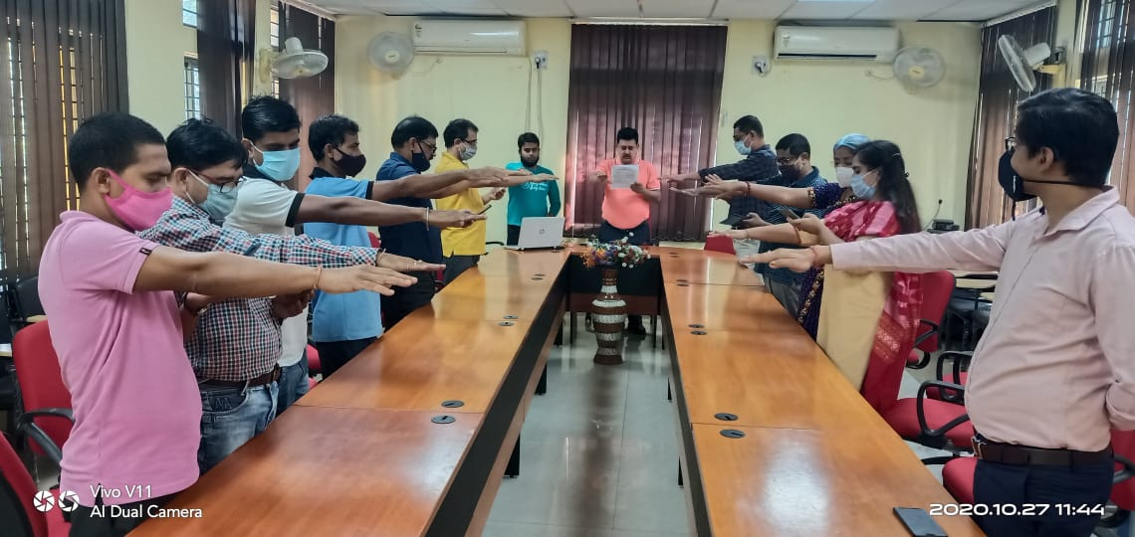

(Source: ICAR-Agricultural Technology Application Research Institute, Kolkata)

