ICAR-ATARI Kolkata organized a webinar on “New Farm Act, 2020 for benefit of farmers”

October 29th, 2020

ICAR-ATARI Kolkata organised a webinar on “New Farm Act, 2020 for benefit of farmers”. Dr. S. K. Roy, Director, ICAR-ATARI, Kolkata presented a brief overview of three new farm acts and its new regulation which will create an ecosystem where the farmers and traders will enjoy the freedom of choice of sale and purchase of agri-produce and promote barrier-free inter and intra-state trade and commerce outside the physical premises of markets notified under State Agricultural Produce Marketing legislations. The webinar was conveyed by Dr. P. P. Pal, Principal Scientist, ATARI Kolkata. Dr. N.C. Sahu, Head, Sasya Shyamala KVK, West Bengal presented a detailed perspective on the new farm acts 2020. He tried to negate the controversy/ barrier related to these new farm acts by citing examples related to contractual farming by private companies working for potato chips and malt barley. He also stressed on provision of freedom of choice to sell and buy the produces outside the AFMC (mandis) by the farmers in this new farm act. Prof. Debashis Sarkar, Head, Dept. of Agricultural Economics, Visva Bharti as expert gave detailed inputs about the three farm acts 2020 viz Farmers' Produce Trade and Commerce (Promotion and Facilitation) Act, 2020, the farmers (Empowerment and Protection) Agreement on Price Assurance and Farm Services Act , 2020 and the Essential Commodities (Amendment ) Act, 2020. These acts for the first time are based on the market trends. He elaborated different aspects of acts and its sub sections like quality, grade and standards of farming produce, sale or purchase of farming produce, exemptions with respect to farming produce, mechanism for dispute resolution, farming agreement fail to settle their dispute within a period of thirty days by the Sub-Divisional Magistrate who shall be the Sub-Divisional Authority for deciding the disputes under farming agreements etc. He reiterated the need of these acts which will directly benefit the farmers further fulfilling the vision of 'One Nation-One Market'. An open discussion was also conducted wherein queries received through chat were placed before the experts by the conveyer.

The webinar was attended by all KVKs of West Bengal, their SMSs and farmers. Additionally, the event was streamed live on official Face book page of ICAR-ATARI Kolkata, which recorded a viewership of nearly 100 people including several farmers, farm societies etc.

Dr. P. P. Pal, Principal Scientist, ICAR-ATARI, Kolkata gave vote of thanks.

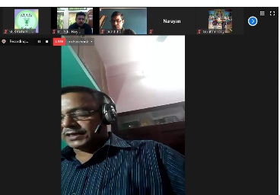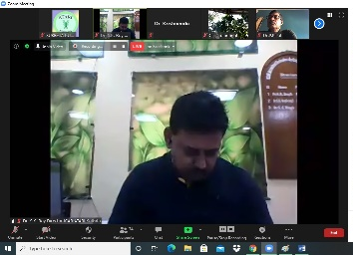

(Source: ICAR-Agricultural Technology Application Research Institute, Kolkata)

