NATURAL RESOURCE MANAGEMENT
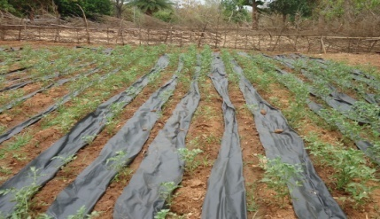 | 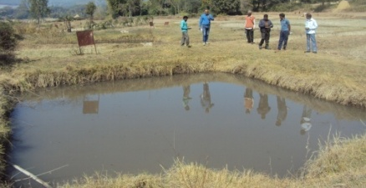
Plastic Mulching | 5% Model
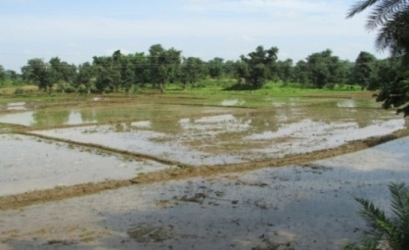 | 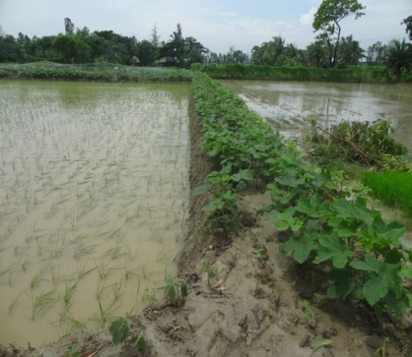
Bunding in Paddy Field
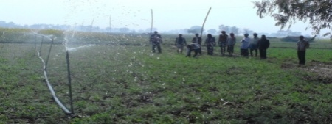 | 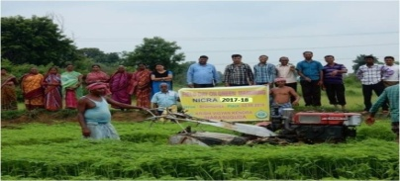
LEWA in field | Brown manuring

CROP PRODUCTION
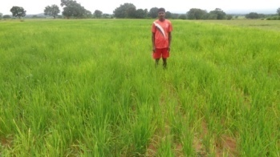 | 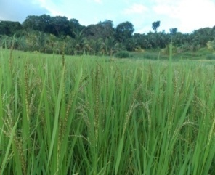
Anjali | CARI Dhan 5
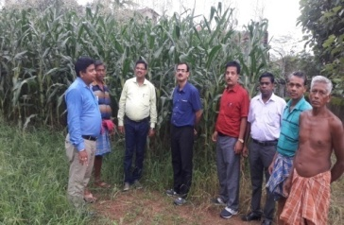 | 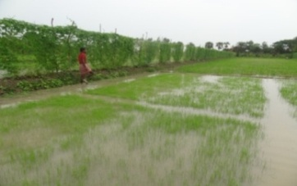
Crop diversification by Hybrid Maize | Sabita

LIVESTOCK AND FISHERIES
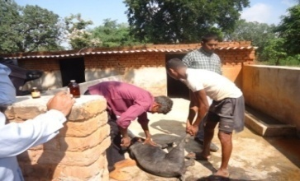 | 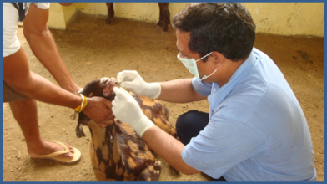
Programme of Animal Vaccination
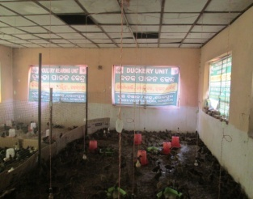 | 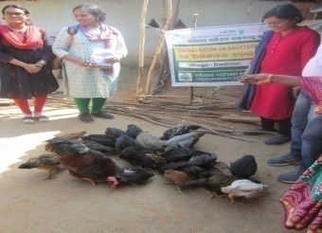
Poultry unit | Kuroiler Breed

INSTITUTIONAL INTERVENTION
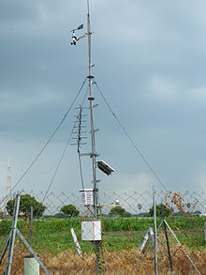 |  | 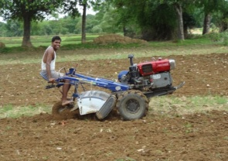
AWS | Seed Bank | Power Tiller

VILLAGE CLIMATE RISK MANAGEMENT COMMITTEE (VCRMC)
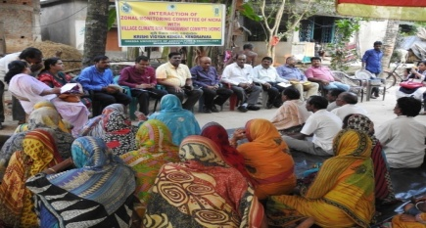 | 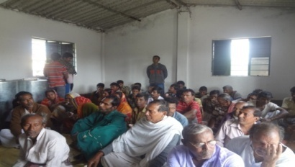 | 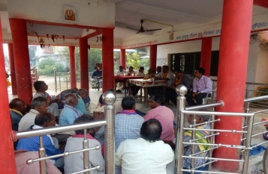
VCRMC Meeting in NICRA villages

CUSTOM HIRING OF FARM IMPLEMENTS AND MACHINERY AT NICRA ADOPTED VILLAGES
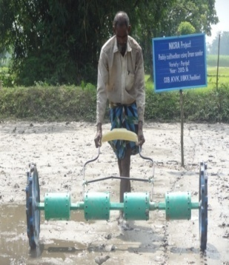 | 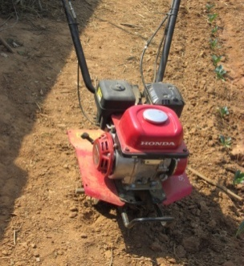 | 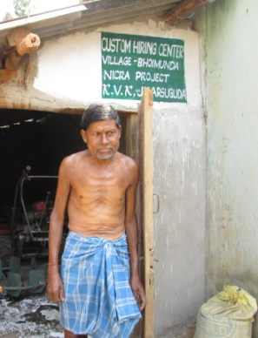 | 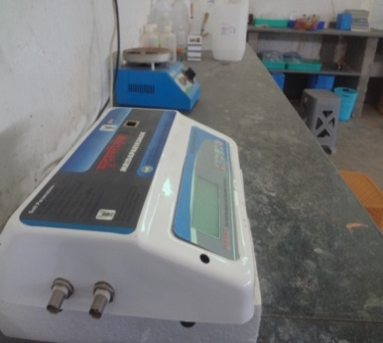
Farm implements in Custom Hiring centers

CAPACITY BUILDING
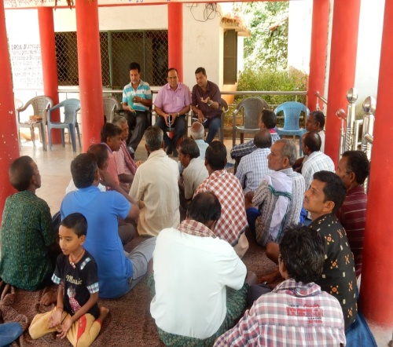 | 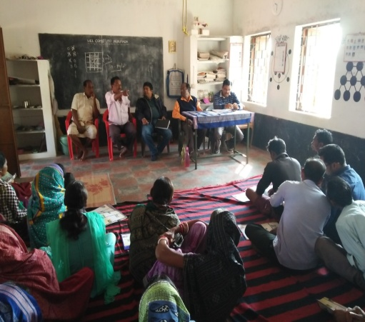 | 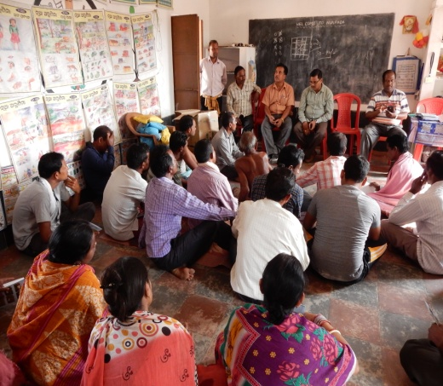
Capacity Building programme conducted in NICRA adopted villages

EXTENSION ACTIVITIES
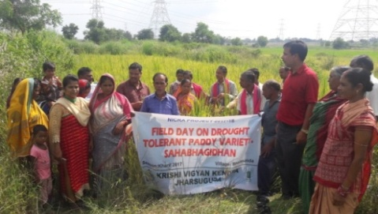  Field day on Sahabhagi Dhan | 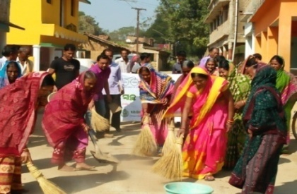  Awareness campaign on Swachha  Bharat Abhiyan
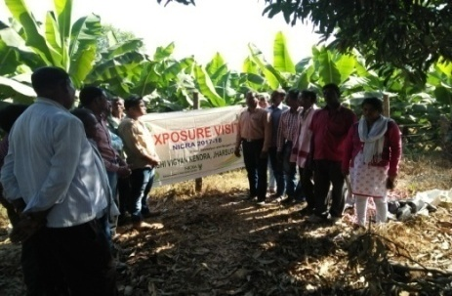  Exposure visit of farmers under NICRA Project | 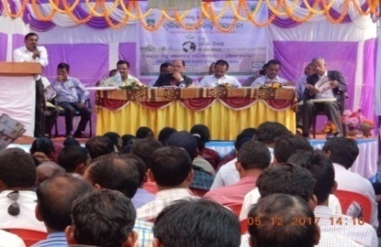  Soil health Card Distribution
CONVERGENCE BY NICRA WITH ONGOING DEVELOPMENT PROGRAMMES
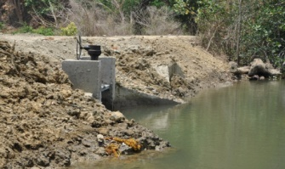 | 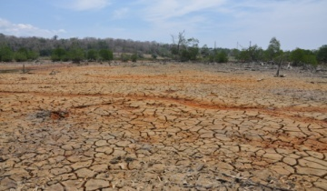
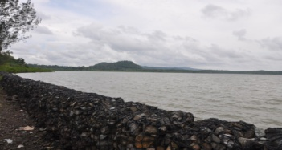 | 