Quality photographs of CFLD Pulses 2018-19:
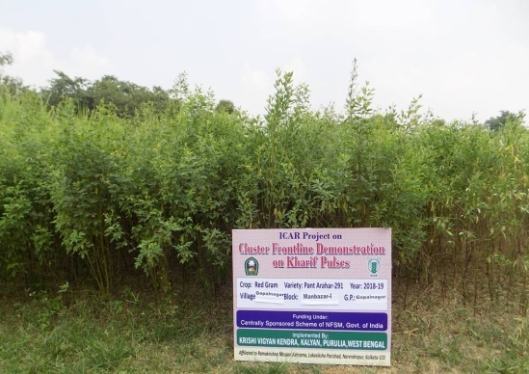 | 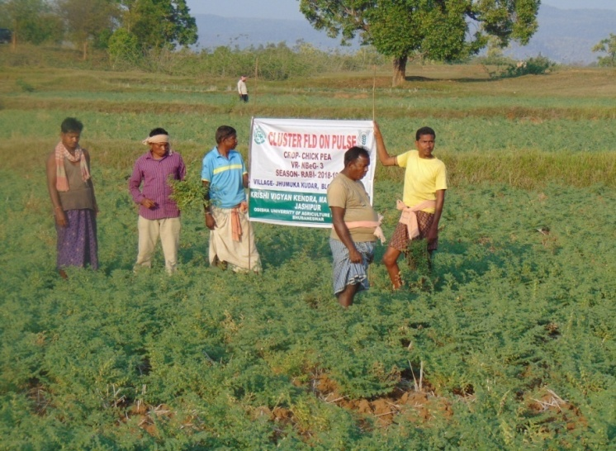 | 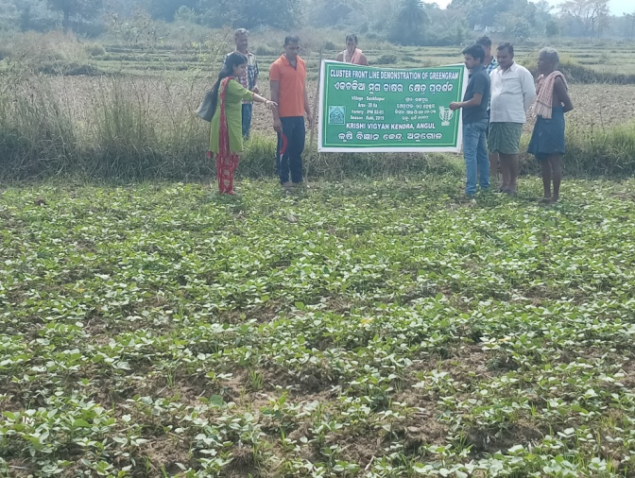
Vegetative stage of Pigeon pea,  KVK Purulia | Vegetative stage of Chick pea,  KVK Mayurbhanj II | Diagnostic visit in Green gram field ,  KVK Angul
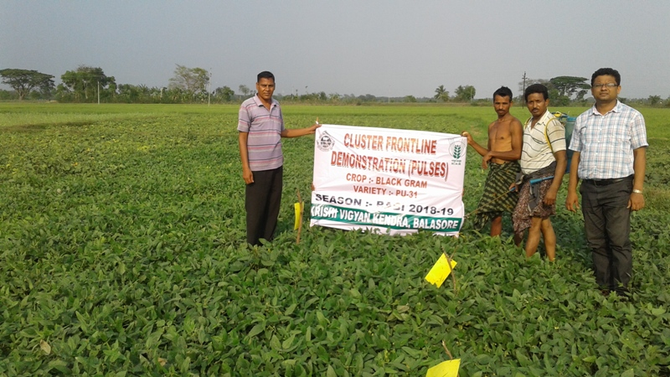 | 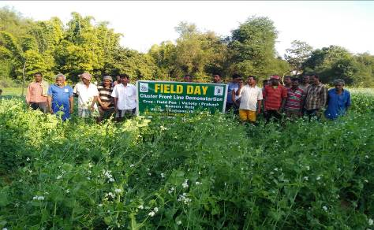 | 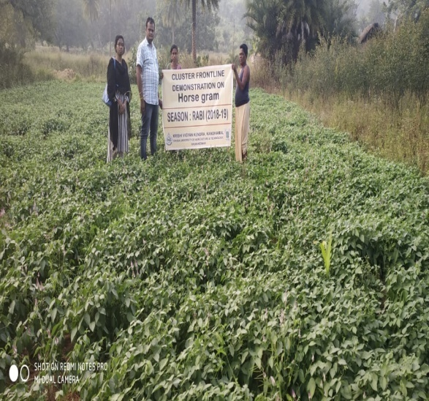
IPM approach in Black gram ,  KVK Balasore | Field day Field pea,  KVK Sundergarh II | Vegetative stage Horse gram,  KVK Kandhamal
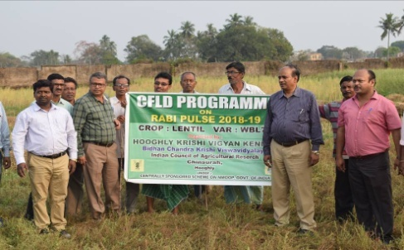 | 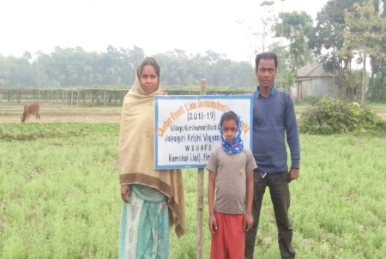 | 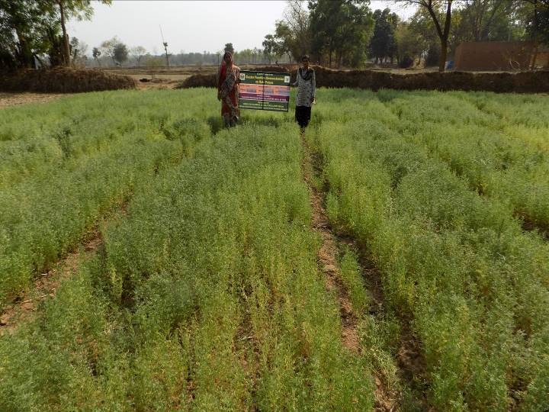
CFLD on Lentil, KVK Hooghly | CFLD on Lentil, KVK Jalpaiguri | Lentil  KVK Purulia
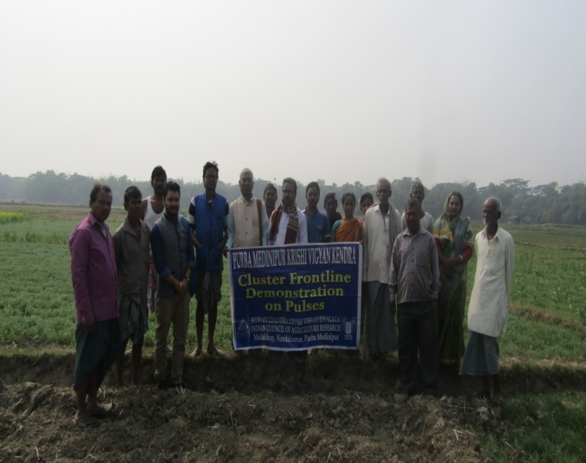 | 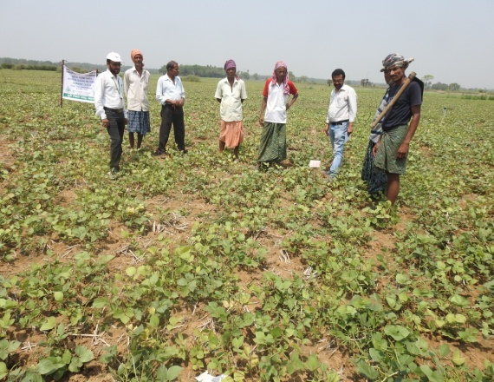 | 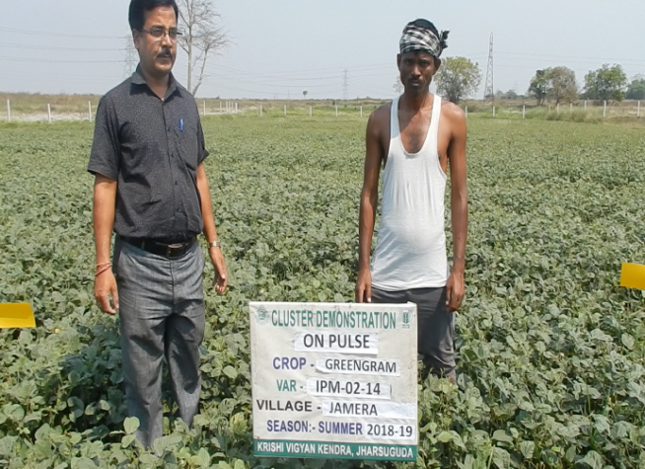
Off campus training (Lentil)  KVK Puba Medinipur | Green gram (summer)  KVK Bhadrak | Green gram (summer) ,  KVK Jharsuguda

