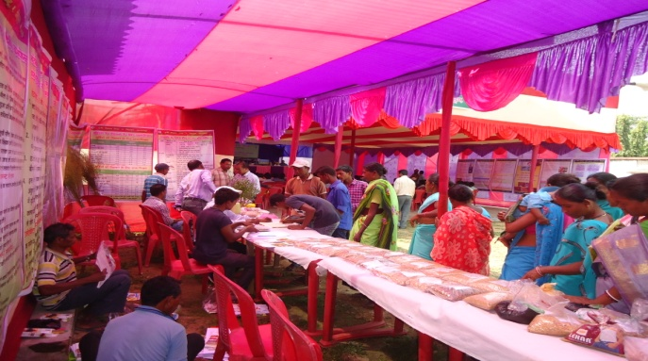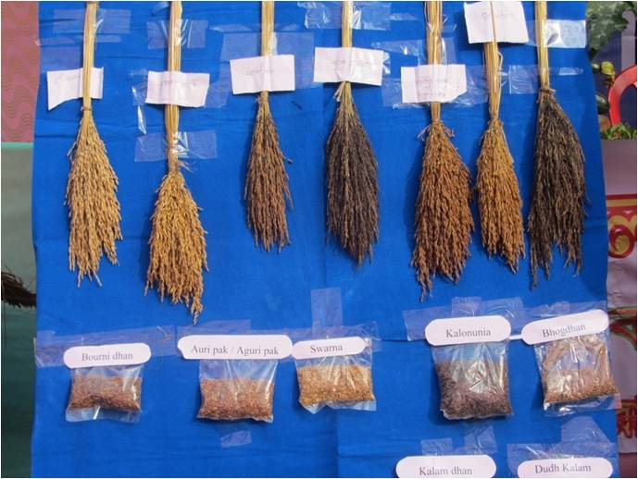

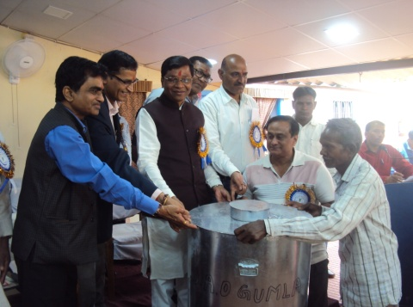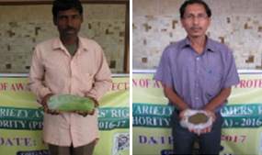

**PPVFR programme at West Singhbhum KVK**

Farmer’s variety displayed at Jalpaiguri KVK

**Identified crop variety at KVK Nimpith**

**Seed drum distribution to selected farmers by Hon’ble guests at Gumla KVK**

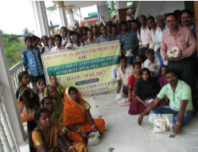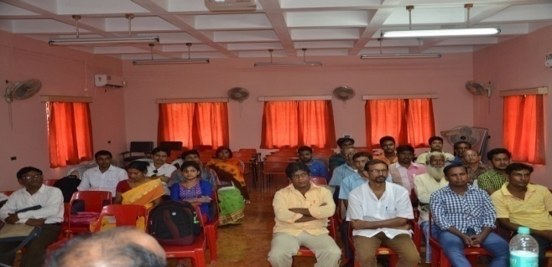

**Participants present in the programme at Nimpith KVK**

**Participants present in the programme at Nadia KVK**